EXP NO 5: CREATE A SIMPLE CLOUD SOFTWARE APPLICATION FOR LIBRARY BOOK RESERVATION SYSTEM FOR SIMATS LIBRARY USING ANY CLOUD SERVICE PROVIDER TO DEMONSTRATE SAAS

AIM: To Create a simple cloud software application for Library book reservation system for SIMATS library using any Cloud Service Provider to demonstrate SaaS

PROCEDURE:
Step1: Go To Zoho.Com.
Step 2: Log Into The Zoho.Com.
Step 3: Select One Application Step.
Step4: Enter Application Name As Library Book Reservation System.
Step 5: Created New Application As Library Book Reservation System.
Step 6: Select One Form
Step 7: The Software Has Been Created.

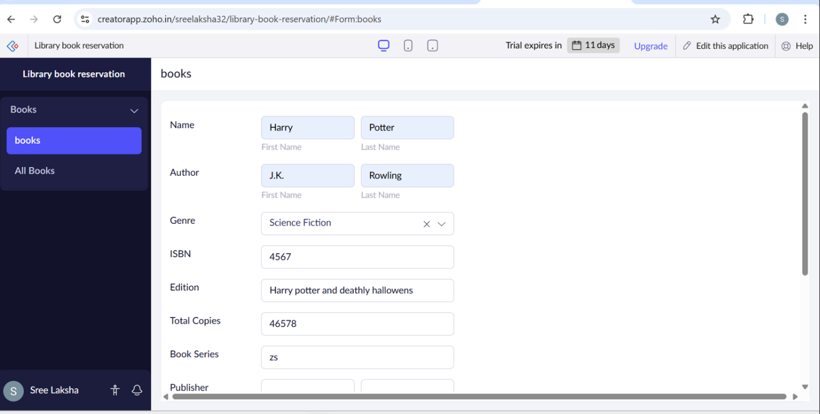
IMPLEMENTATION:
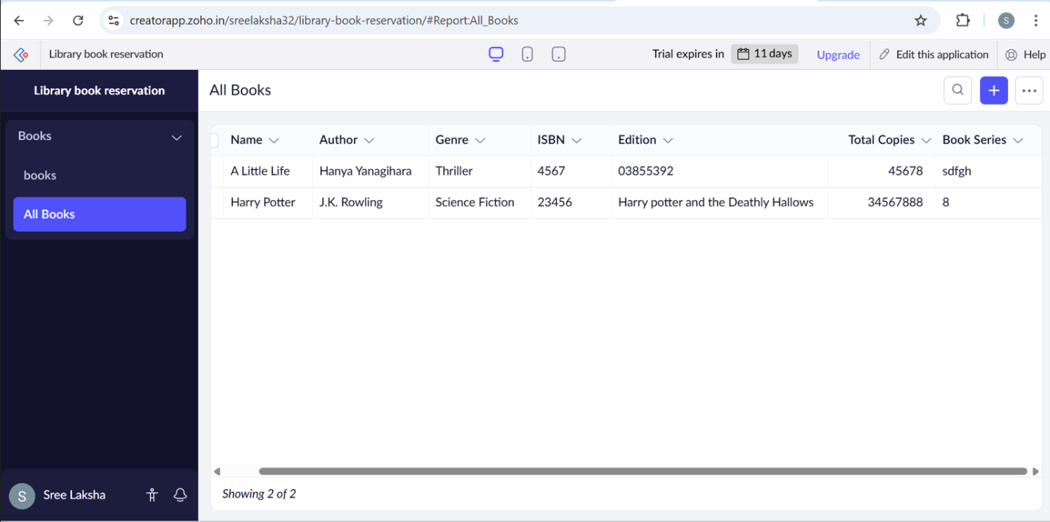
OUTPUT:

RESULT:
Thus a simple cloud software application for library book reservation system for Simats library using any cloud service provider to demonstrate Saas was done successfully.

